**SP/RM[1,1] – Decomposition Cortland Watson**

**Type in your score here 🡪 __37__ out of 37 points possible**

1. (5 points) Ponder/Reflect Exercise – Reflect on what you have learned from this portion of the class. Examples of what you can do are: a brief outline of material covered, insights you gained from class or personal study, or items you feel that you need to follow up or work on. (3-5 sentences)
   1. This week I have been able to learn the difference between split plot and complete blocking. The main difference that I have found with blocking and with the split plot is that there are more combinations that we consider for analysis. Although we might be using two things to group the factors, we consider all possible interactions and combinations when looking at the analysis.
2. #C1(a,b,c,e) on page 266 (2 points each)
   1. The sponges are the whole plot
   2. Sponge color is block
   3. Location tested is the within plot
   4. 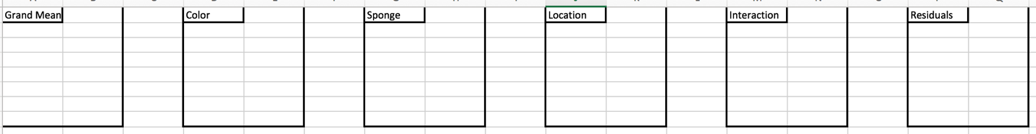
3. Consider the experiment described in Example 7.11 on page 261, with data given on the bottom of page 281.
   1. (4 points) The following is known about the analysis: mean of all observations = 21.25, SSplants = 483.75, SSdeblading = 24.5, SSinteraction = 265.75, SSresidual = 42.75, SStotal = 16194.
   2. Using what you know about the design of the experiment and the information above, give the complete ANOVA table for the data including appropriate F-statistics and p-values. (You will want to use `1-pf(F-statistic, df1, df2)' in R to find the p-values.)
      1. 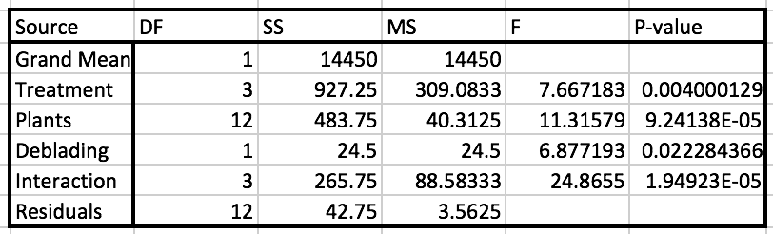
4. (4 points) #D1 on pages 278-9
   1. 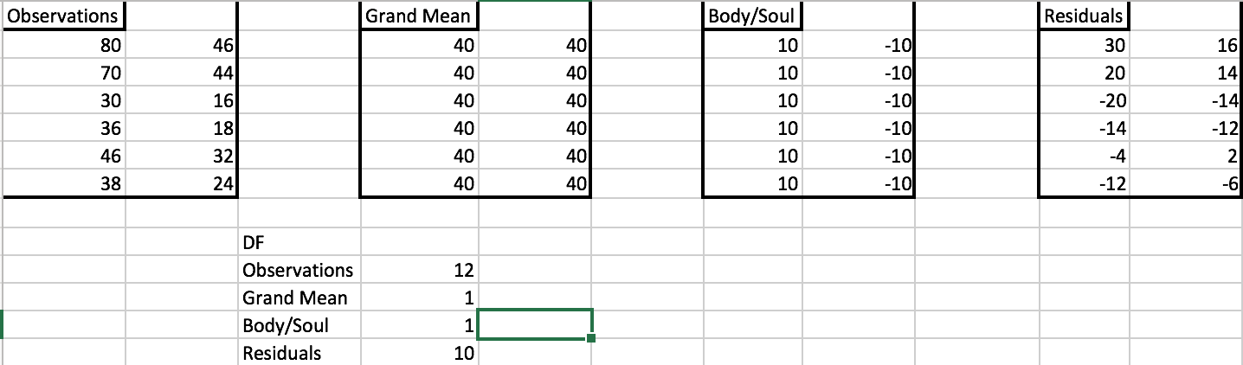
5. (4 points) #D2 on pages 278-9
   1. 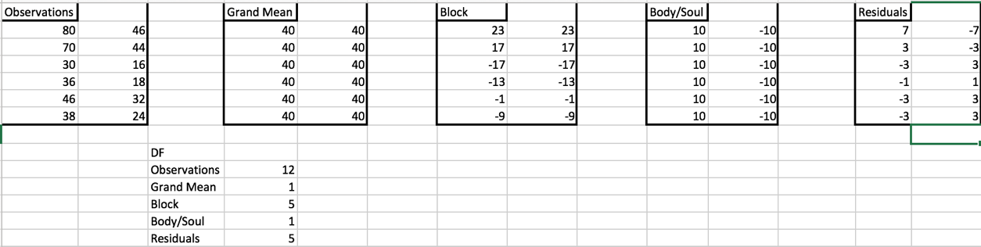

1. (4 points) #D3 on pages 278-9
   1. 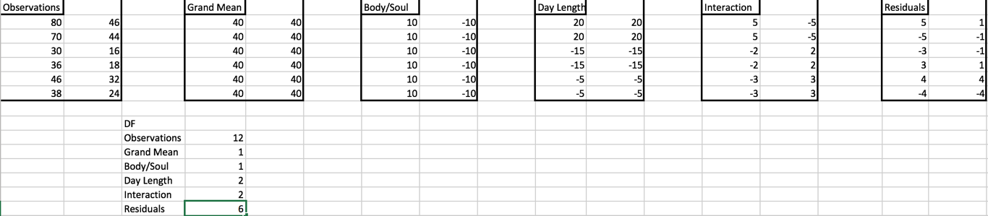
2. (4 points) #D4 on pages 278-9
   1. 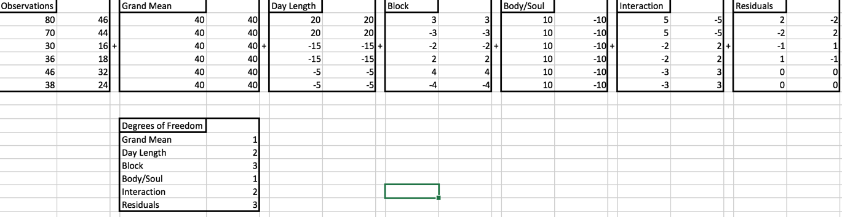
3. (4 points) #D11 (this is a SP/RM[1;1]) NOTE: With the information given, it is impossible to fill in the last two rows of the table for “Block.” Just do the rest of the problem on pages 278-9
   1. 